**Cloud Services:**

Collection of multiple servers which is managed by cloud service providers.

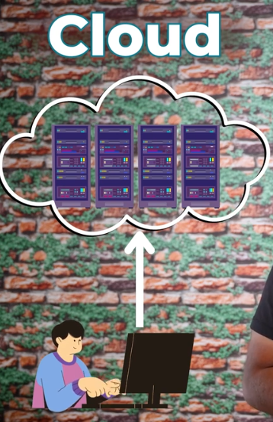

In previous days, people used to go hardware market and buy the servers and all the other best hardwares required to setup the servers in their place and manage it 24/7. This type of using servers is called On-Premises.

But that is difficult to do and maintain. It costs money, can’t scale the servers for a short limited period of time, also costs more for memory and RAM of servers.

So, the cloud providers started their own cloud and we just need to deploy our app and use it there.

The highlight is, we don’t need to pay a big amt to use the cloud. Based on the no of users of our app, the money will be deducted from the cloud itself, which is very less.

So the main advantage of cloud is low cost and more efficiency(eg: can scale up the required service easily).

In, On-Premises:

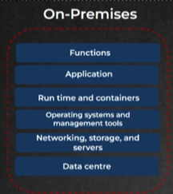

We have to manage everything in On-Premises. Both hardware and software.

In Cloud Services, we have 5 types,

1.IaaS(Infrastructure as a Service)

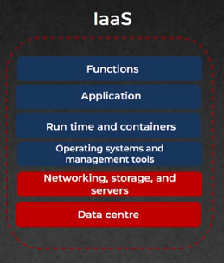Red-provided by Cloud; Blue-We need to take care.

2. Caas(Container as a Service)

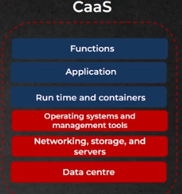

3.Paas(Platform as a Service):

We as developers mostly use PaaS and then CaaS. It contains OS, runtime inbuilt so that we can just create and deploy our app.

4. Faas(Function as a Service):

5.Saas(Software as a Service):

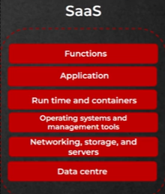

Most of the cloud apps are Saas, like gmail, google docs etc.. Users can access it through the internet, usually via a web browser.

**Drawbacks** of Cloud Service(public server) is security. Since the cloud providers have our app in a common hardware(server) which also serves for other apps, it can be hacked.

But then On-Premises server(private server) costs huge.

So the solution is Hybrid server, where we will have both On-Premise and Cloud server and we will store confidential data in On-Premise server and other services in cloud server.

**Services in AWS site:**

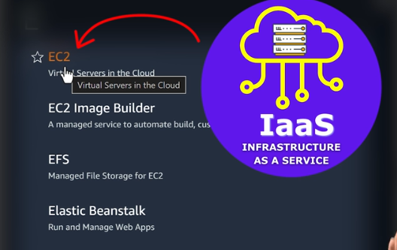

This is what we use to deploy our application.

Also there are many other services available in AWS site.

**IAM(Identity and Access Management):**

You can see this in All Services or you can just search this service.

https://739275484104.signin.aws.amazon.com/console

To build and deploy, we cant just do it with root server. We have to create a user in IAM and copy the link and open it and login from that link.

Then we have to create a role(EC2) with permissions